**[Exploring Weather Trends](https://github.com/SThornewillvE/Udacity-Project---Exploring-Weather-Trends)**

**==========================**

In this project, we analyze weather trends data for Alexandria Egyptian city **using** SQL, moving averages, and data visualization

The below steps clarifying each process:

**Exploring and Extracting the Data Using SQL**

* **Exploring Data Using SQL**

**I used the below query to explore my data**

SELECT *

FROM city_list;

SELECT *

FROM city_data;

SELECT *

FROM global_data;

Try to find my city Amman from Jordan, but it had not included in city_list **SO** I choose Alexandria from Egypt.

* **Create the SQL query**
* **Rename columns for joining**

ALTER TABLE global_data RENAME COLUMN avg_temp to global_avg_temp;

ALTER TABLE city_data RENAME COLUMN avg_temp to city_avg_temp;

* **Select the desired data BY using an inner join.**

SELECT global_data.year, global_data.global_avg_temp, city_avg_temp FROM global_data INNER JOIN city_data ON global_data.year=city_data.year WHERE city ='Alexandria';

* **Exporting SQL data to CSV then Excel file**

**Submission Outline:**

= = = = = = = = = =

**The Tools:**

**SQL,** for exploring and extracting the data.

**Excel**, to calculate the moving average and visualize the trends.

**Calculating the moving average:**

Using Average () function in Excel with 10-year period gap.

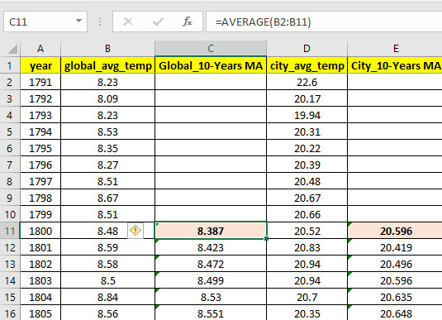

**Key Considerations:** we focus on visualize our data and get a sense of the trends by

**Using a moving average,** to smooth out the volatility and observe the long term trend in easy way without losing the yearly fluctuations, so our chart looks clear to interpret.

**Using a Line graphs**, to focus on comparison of the moving average for Alexandria city and global temperature trends to interpret and make our Observations.

**Line Chart**: Using Line graphs can show changes over time so

**Clearly,** help us to make comparison of our items (the moving average for Alexandria city and global temperature trends).

**Determine,** the relationship between two sets of values, with one data set always being dependent on the other set.

**Observations:**

**The First,** we noticed that **both** the moving average for Alexandria city and the moving average global temperature have **similar** type of trends in early years (both of trends have ups and downs) then around 1850 we also notice that the moving average temperature begun to increase in steady rate.

**The Second,** Also, from looking to the Line Graph carefully, we can notice that from 1990 approx. the temperature is increasing in faster rate on **both** trends compared to the early 1900's.

**The Third,** we noticed **difference** that the total moving average for global temperature is low compared to the moving average for Alexandria city. So that means the Alexandria city is considerably hotter than the rest of the world in terms of the moving average global temperature.

**The Fourth,** From the chart, we can notice **difference in especial period (1790-1800)** where we find unique increasing temperature in the moving average for Alexandria city with minimum moving average 11.6, maximum 16.3 and average 13.9 which consider as significant gap increasing while comparing with smooth increasing in the moving average global temperature with minimum moving average 8.1, maximum 8.4 and average 8.3.